**SCHEMATIC DESIGN**

In this tutorial, you will walk through step by step how to create a schematic design in Altium. In this case, we will be designing a simple breakout board for the RS-232 part.

1. First step is to create your project. To do this, click on File > New > Project…

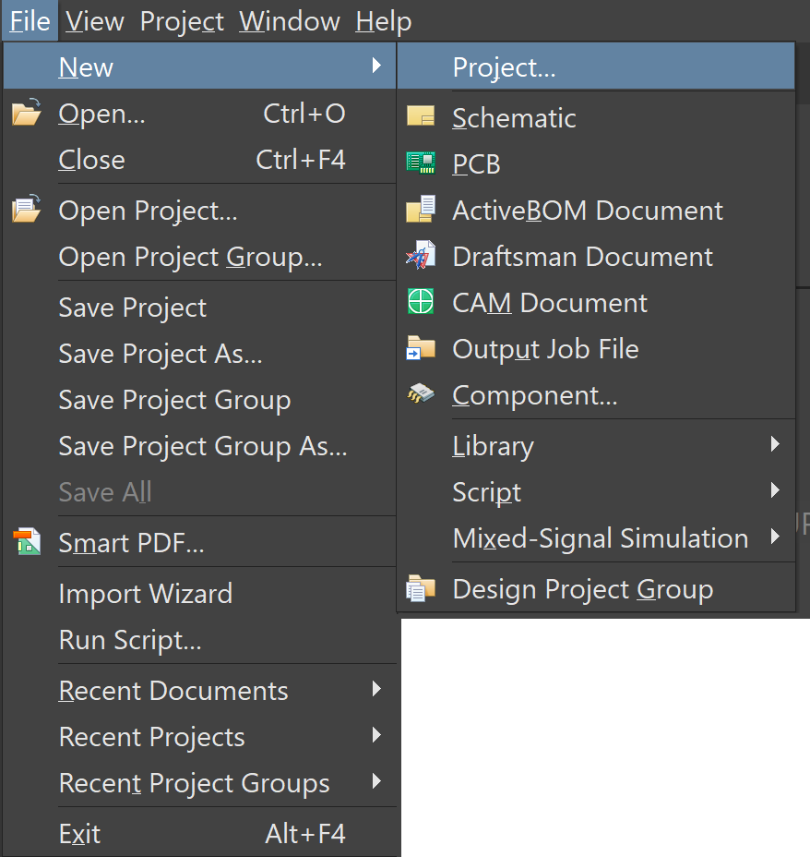

*Figure 1: Path to Select New project*

1. You will see a start-up screen like the one in Figure 2. For now, just select the default Project type.
2. Save your project name and location however you’d like.

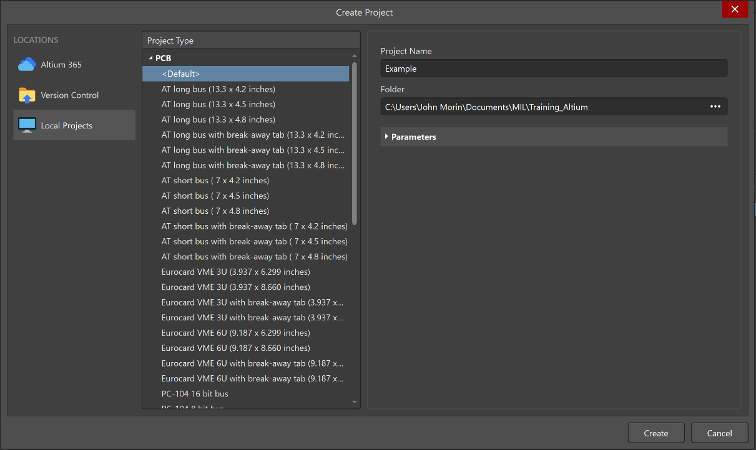

*Figure 2: New Project Start Up Screen*

1. Right click on the name of your project on the left side of your screen (if not visible select View > Panels > Projects). Click on “Add New to Project” and then “Schematic” as shown below.

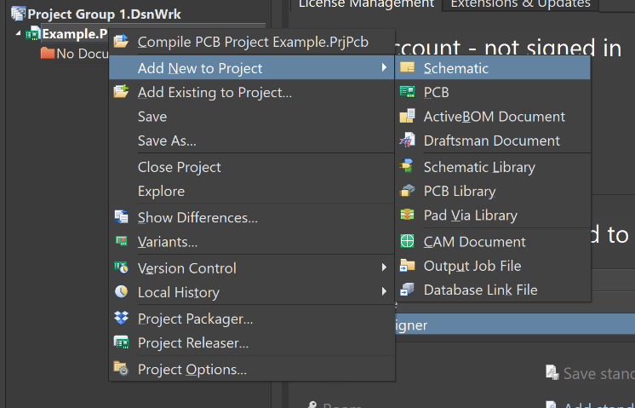

*Figure 3: Path to Select New Schematic*

1. You should now see a blank grid representing your schematic. Save this schematic as whatever you want.
2. Now we will link our relevant libraries to Altium (assuming your GitHub is installed and up to date).
3. Go to the left side of your screen and click on the “Components” panel (if not visible go to View > Panels > Components).
4. There, click on the three horizontal bars at the top right of the panel and select “File-based Libraries Preferences…”

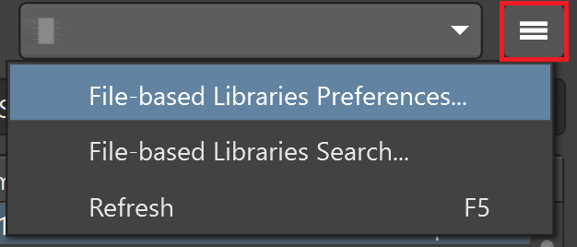

*Figure 4: Path to Open Library Preferences*

1. On the bottom right side of the pop up, press the install button.

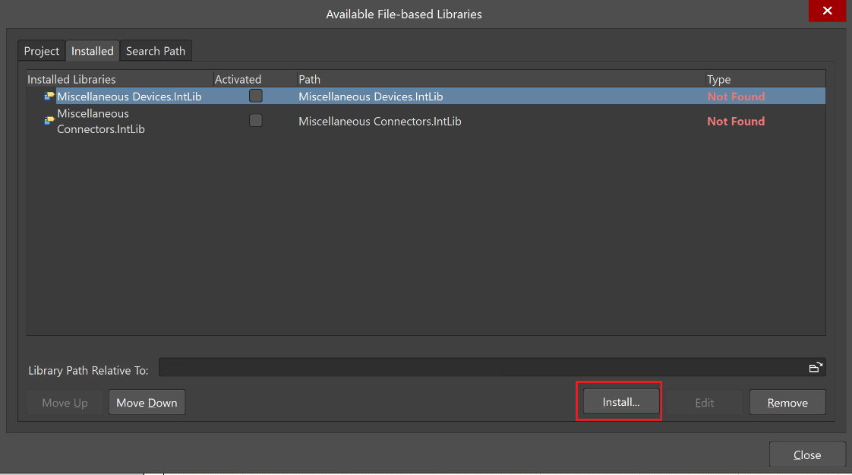

*Figure 5: Library Installation Window*

1. Follow the path to where your GitHub base is stored and go to SVN Legacy > MIL SVN > Libraries.
2. Select all the files highlighted in Figure 6, then press okay.

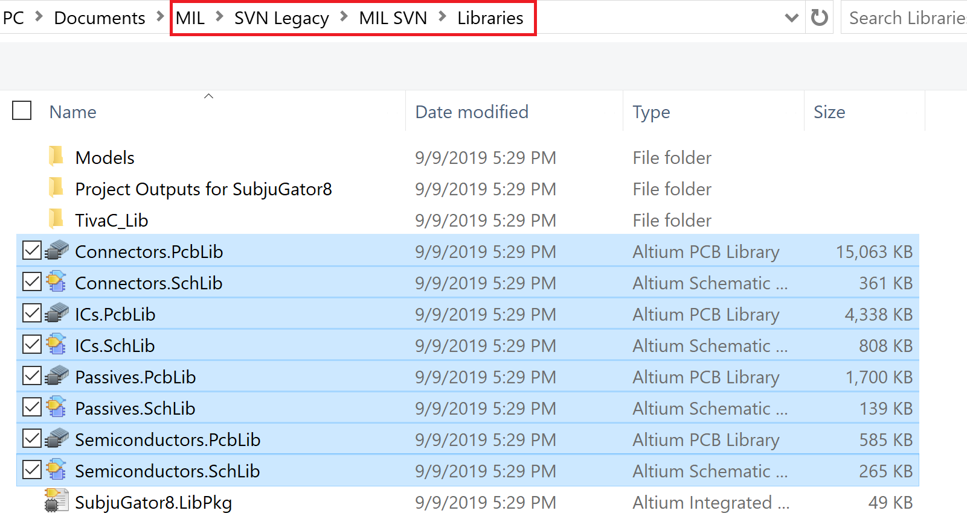

*Figure 6: Main Libraries*

1. Double click on the “TivaC_Lib” folder and select the files highlighted in Figure 7.

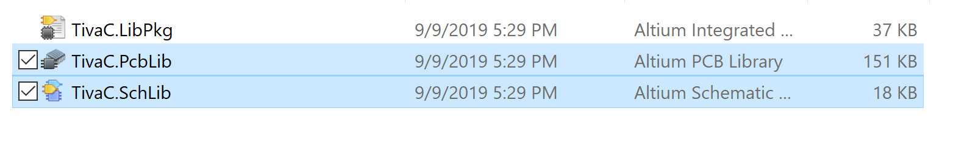

*Figure 7: Tiva Libraries*

1. Close the pop-up.
2. Select the “ICs.Schlib” library from the drop-down menu and type “RS-232” into the search bar. You should see a screen similar to Figure 8.
3. Select the option labelled “RS-232” and drag it onto your schematic. (You will have red squiggles next to your component once placed on the schematic, for now that’s okay)

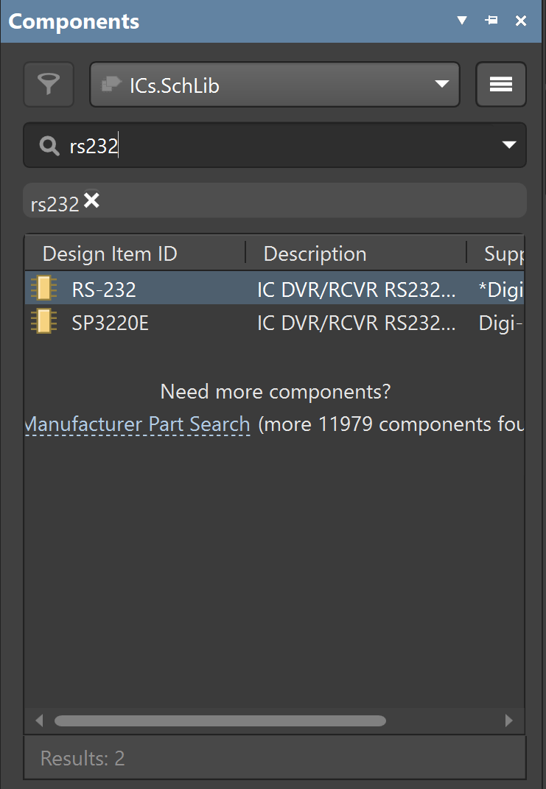

*Figure 8: RS-232 Part under “Components”*

1. Now select “Passives” in the drop-down menu and search for “caps”. Drag five capacitors onto your screen.
2. Select “Connectors” in the drop-down menu and search for “headers”. Select the connector labelled “MOLEX-HDR-1x5-SHERLOCK_VERT” and drag two onto your screen.
3. Organize your components as specified in Figure 9. (hint: you can rotate a component by selecting it and pressing the space key)

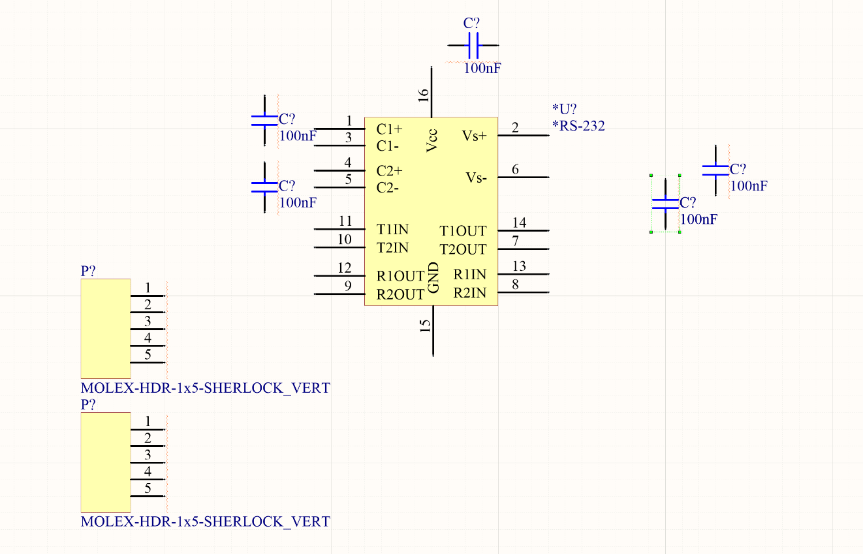

*Figure 9: Initial Schematic Layout*

1. Next, we will place our power and ground.
2. Right click on the ground symbol on your top toolbar as shown in Figure 10.

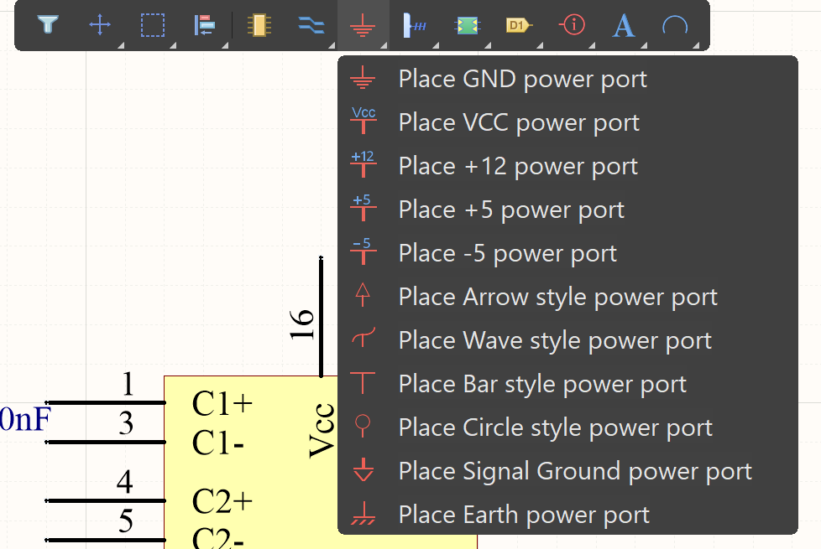

*Figure 10: Path to Select Ground Node*

1. Select “Place GND power port” and place it in the locations specified in Figure 11.
2. Follow the same process in step 20 but now select “PLACE VCC power port”.
3. Place it in the locations specified in Figure 11 and double click the components to label them as “5V”.

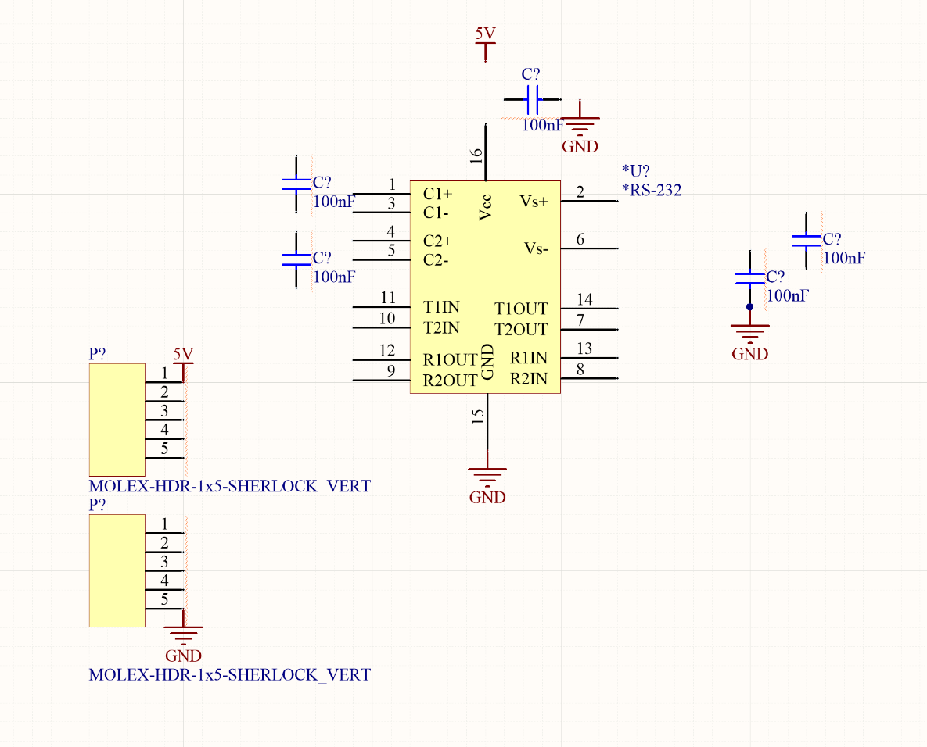

*Figure 11: Updated Schematic with Ground and VCC Nodes*

1. Next, we will begin attaching our components together with wires.
2. Right click on the wire icon on the toolbar and select “Wire” as shown in Figure 12.

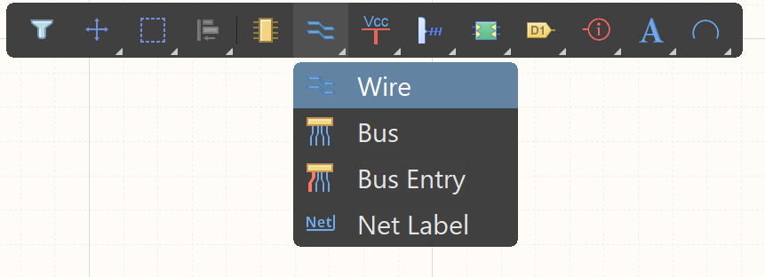

*Figure 12: Path to Select Wires*

1. Connect your components together as shown in Figure 13. In addition, make sure to add wires to extend the floating pins of your RS-232 chip.

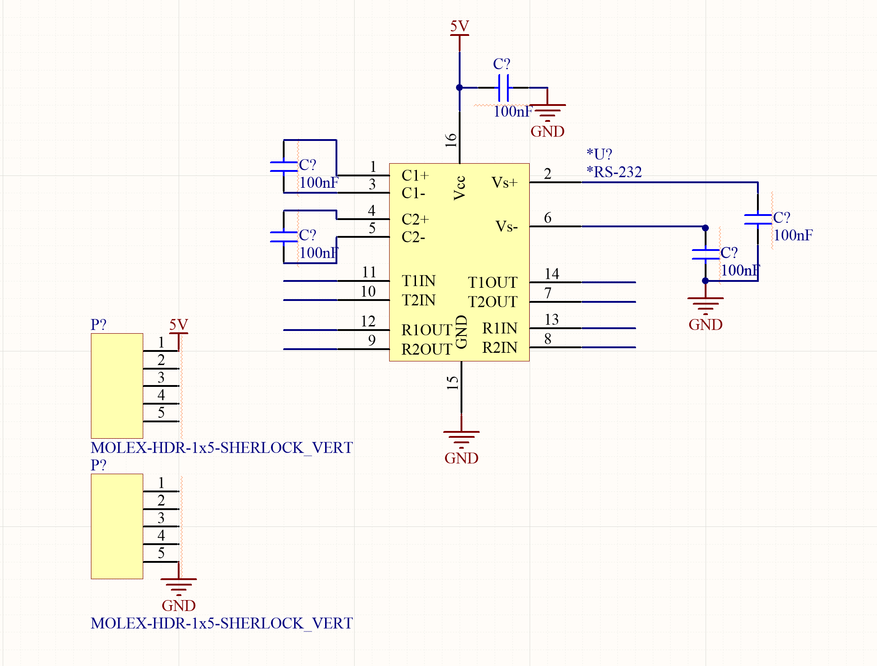

*Figure 13: Updated Schematic with Added Wiring*

1. Now we will add labels to connect nodes together without having to draw wires between them.
2. Perform step 25 again but this time select “Net label”.
3. Add your labels to the RS-232 pins as shown in Figure 14.

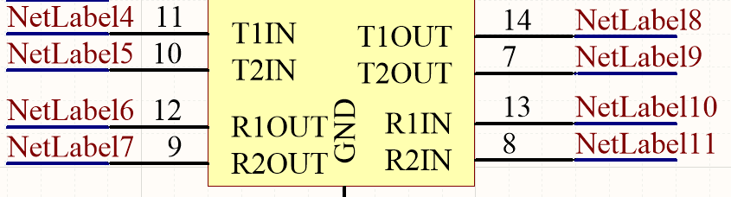

*Figure 14: Added Default Net Labels*

1. Double click on your labels and change them to the pin names on the RS-232 as shown below.

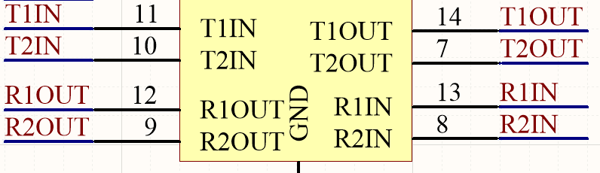

*Figure 15: Customized Net Labels*

1. Perform steps 28-30 again on your connectors to achieve the results in Figure 16.

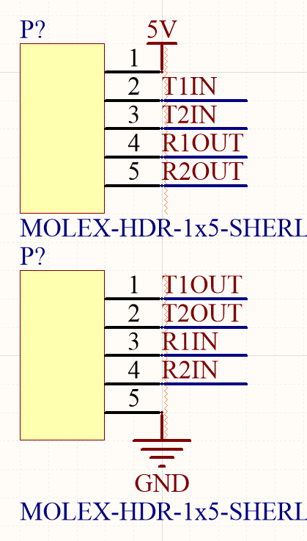

*Figure 16: Net Labels for Connectors*

1. We will next define the values for our capacitors.
2. Double click on one of your capacitors. A “Properties” window should pop up on the side of your window.
3. Select the Parameters tab and move down to the Value parameter. Double click it and change the value to “1uF”.
4. Repeat this process for your other four capacitors. If you did it right, you should end up with a schematic similar to Figure 17.

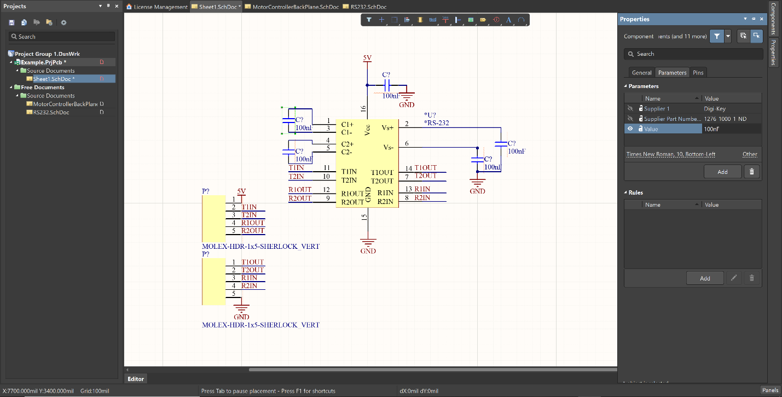

*Figure 17: Screen to Change Capacitor Values*

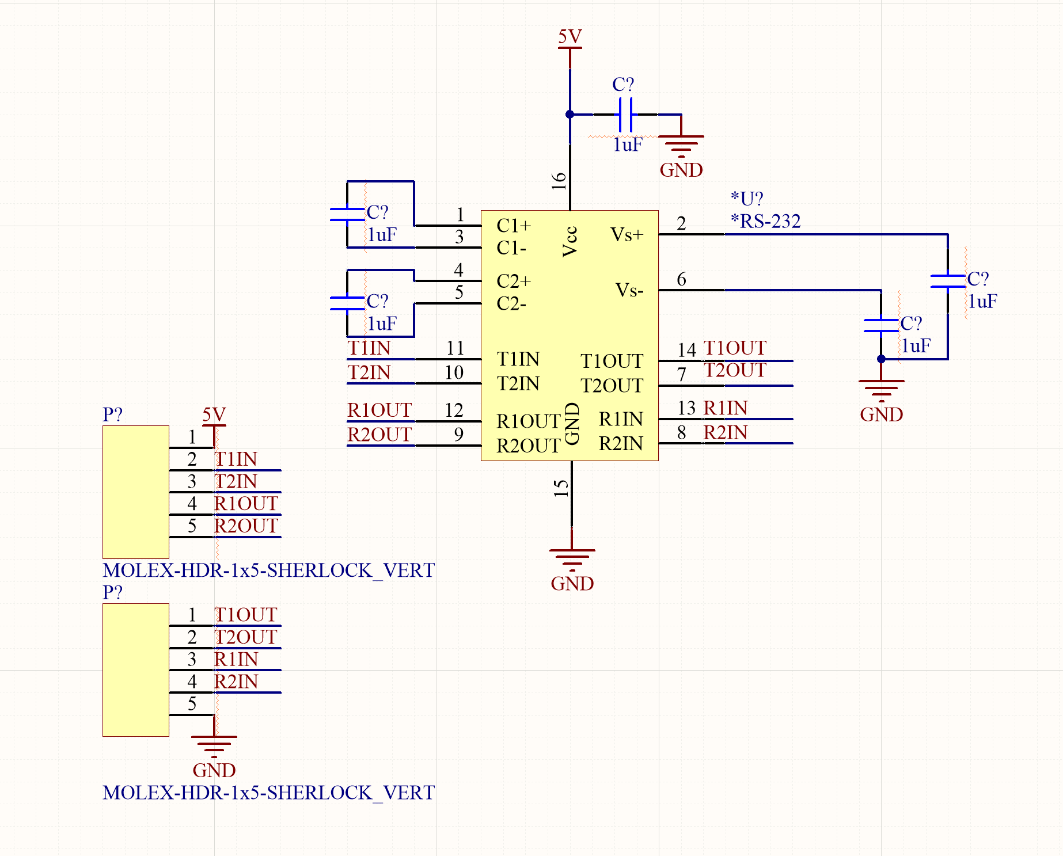

*Figure 18: Updated Schematic with New Capacitor Values*

1. We are almost complete. Now we just need to get rid of those ugly red squiggles. They exist because our parts aren’t annotated (numbered) and therefore not distinguished from each other.
2. While you can individually edit these parts and replace the question marks with numbers, it is much easier to simply select Tools > Annotation > Annotate Schematics Quietly…
3. When prompted whether to continue, select “Yes”.

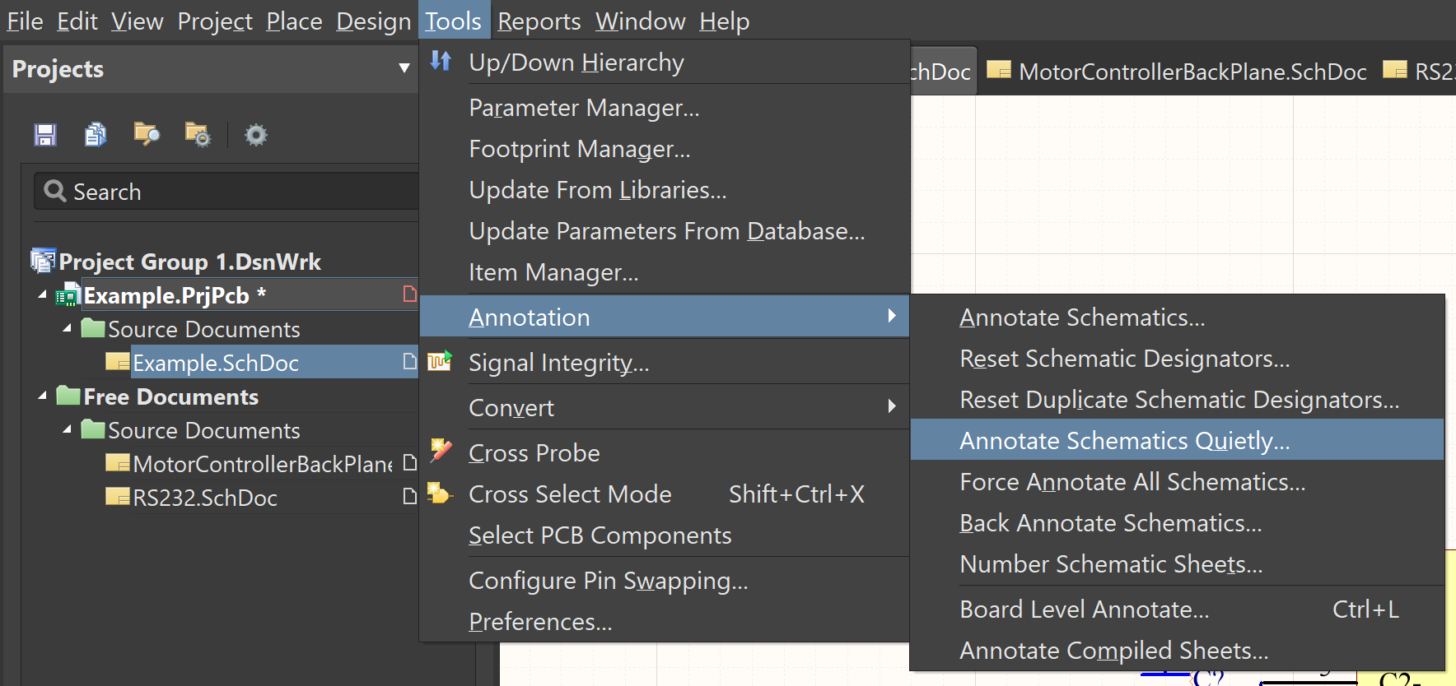

*Figure 19: Path to Annotate Schematic Quietly*

1. Now we’re done! You’ve successfully designed your first schematic in Altium. If you did everything properly your schematic should look similar to Figure 20.

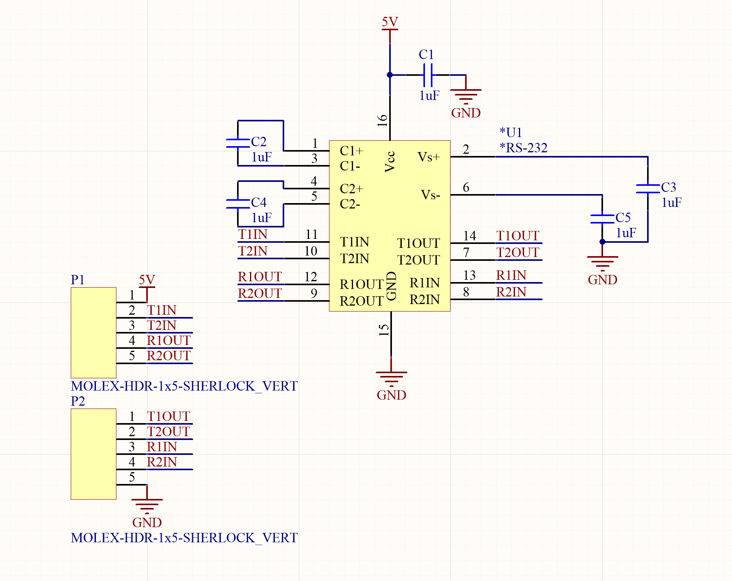

*Figure 20: Completed Schematic Design*

We are about halfway through with designing our first board. Now we need to continue to the PCB (Printed Circuit Board) design process where we will lay out our parts for the manufacturer to print.